Genomic Variations

Overview
Genetic sequence variations in an organism’s DNA may cause corresponding changes in the protein product and affect biological function. Variations may be small scale (e.g. point mutations, inserts, deletions) or large scale structural changes (e.g. copy number variations, inversions). They may also be classified as somatic (i.e. acquired) or germ-line (i.e. inherited). In terms of genetic variations, caBIO currently contains only SNPs, which are point mutations in the germ-line. All SNPs in caBIO are loaded from dbSNP.
In order to expand coverage of variations in caBIO, two additional variation databases are considered:
- Database of Genomic Variants (DGV)
- COSMIC – Catalogue of Somatic Mutations in Cancer

The DGV contains large-scale variations (> 1kb) in healthy samples only. These variations are usually acquired through germ-line mutations.

By contrast, the COSMIC dataset contains small-scale mutations, in tumor samples only (but the tumors may be benign). These mutations are assumed to be acquired somatically in most cases.

Availability in CGWB
The Cancer Genome Workbench (CGWB) currently provides access to a large number of datasets through a user interface based on the UCSC Genome Browser. It includes both of the datasets described above. There is a project currently underway to create a caBIG compatible interface to the CGWB. This interface will allow for access to the COSMIC dataset, but not the DGV, due to resource constraints at this time.

Solution Approach
One of several approaches may be taken to expose this data in conjunction with caBIO. Relevant considerations are listed under each approach.

- Direct import of data into the caBIO model
  - The current caBIO model (Figure 1) does not model non-SNP variations. New classes would need to be added.
  - The ICR DAM provides some stub classes for implementing genetic variations (Figure 2), although they are not very significantly different from caBIO’s existing implementation.

- Federated Query joining the CGWB Grid Service and the caBIO Grid Service
  - In theory, this should be available for “free” once the CGWB Grid Service comes online.

- DAS-like interface to expose CGWB data via the caBIO API
  - Adds a run-time dependency to caBIO, which is currently free of such dependencies. This creates development, QA and deployment issues, and should be evaluated carefully.
  - Performance dependant on CGWB API.
  - The CGWB API will only expose the COSMIC dataset, at least for the time being.
  - What advantages would this confer over a Federated Query?

- Templated Query in the caBIO Portlet
  - Query results should integrate data from caBIO and CGWB so that the interface provides functionality distinct from the CGWB Genome Browser.
  - Performance dependant on CGWB API.

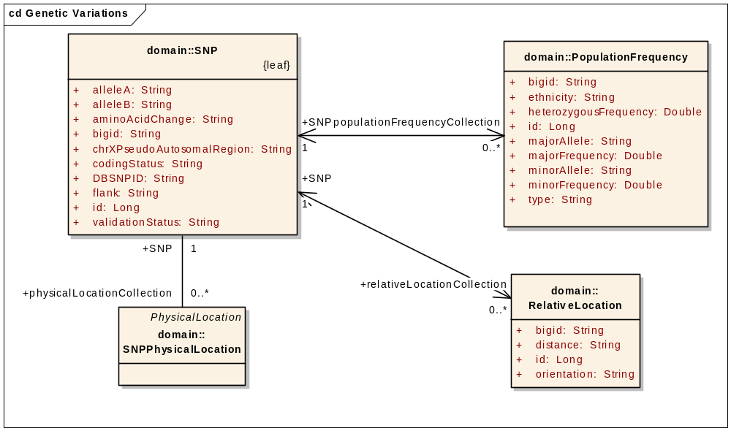
Figure 1: SNP and related classes in the caBIO model

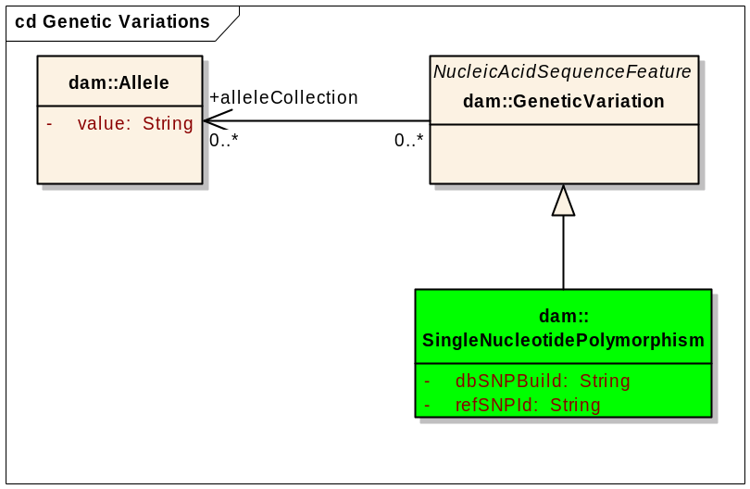
Figure 2: Genetic Variations in the ICR DAM

Tasks
Dependant on the solution approach.

Estimated Level of Effort
Dependant on the solution approach.

References
- Recommendations for the description of sequence variants, http://www.hgvs.org/mutnomen/recs.html
- dbSNP Data Content Information, http://www.ncbi.nlm.nih.gov/bookshelf/br.fcgi?book=helpsnpfaq&part=Content
- COSMIC: Additional Info, http://www.sanger.ac.uk/genetics/CGP/cosmic/add_info/
- Interpreting data in the Database of Genomic Variants, http://projects.tcag.ca/variation/interpreting_data.html

It should be noted that dbSNP contains other variations besides SNPs. The dbSNP FAQ says “Think of dbSNP as a "dbVariation" since it contains not only Single Nucleotide Polymorphism (SNP), but also indels, STRs, MNPs, etc.”
http://projects.tcag.ca/variation/
http://www.sanger.ac.uk/genetics/CGP/cosmic/

